能带计算必备：简约布里渊区形状及特殊K点坐标，直观体现出空间构型

感谢付金彪，吴波收集整理 2009-09-16 17:23:15
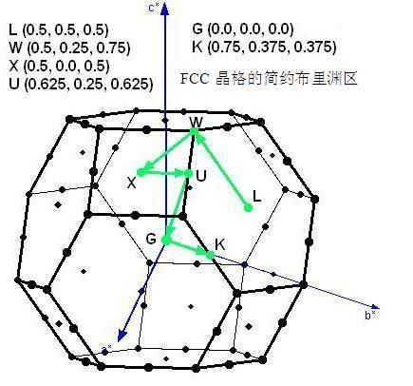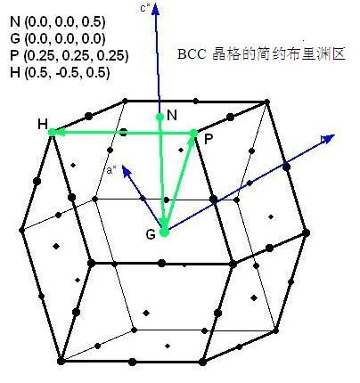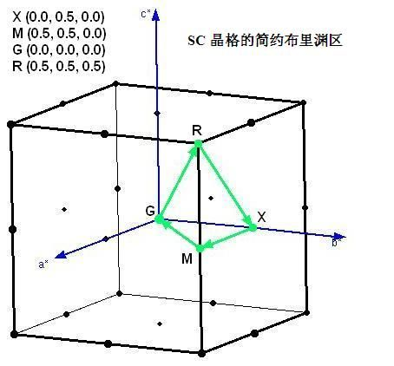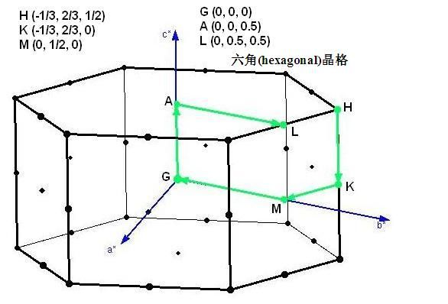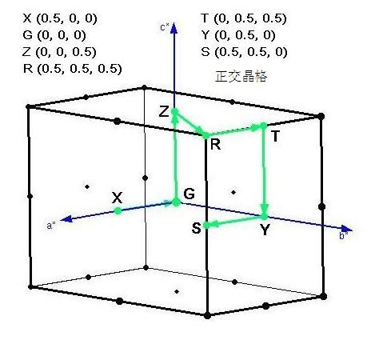
Symbol Description
Γ Center of the Brillouin zone
Simple cube
M Center of an edge
R Corner point
X Center of a face
Face-centered cubic
K Middle of an edge joining two hexagonal faces
L Center of a hexagonal face
U Middle of an edge joining a hexagonal and a square face
W Corner point
X Center of a square face
Body-centered cubic
H Corner point joining four edges
N Center of a face
P Corner point joining three edges
Hexagonal
A Center of a hexagonal face
H Corner point
K Middle of an edge joining two rectangular faces
L Middle of an edge joining a hexagonal and a rectangular face
M Center of a rectangular face

